Temp_detector using Raspberry pi pico &LED

PCB designing.

Schematic diagram:

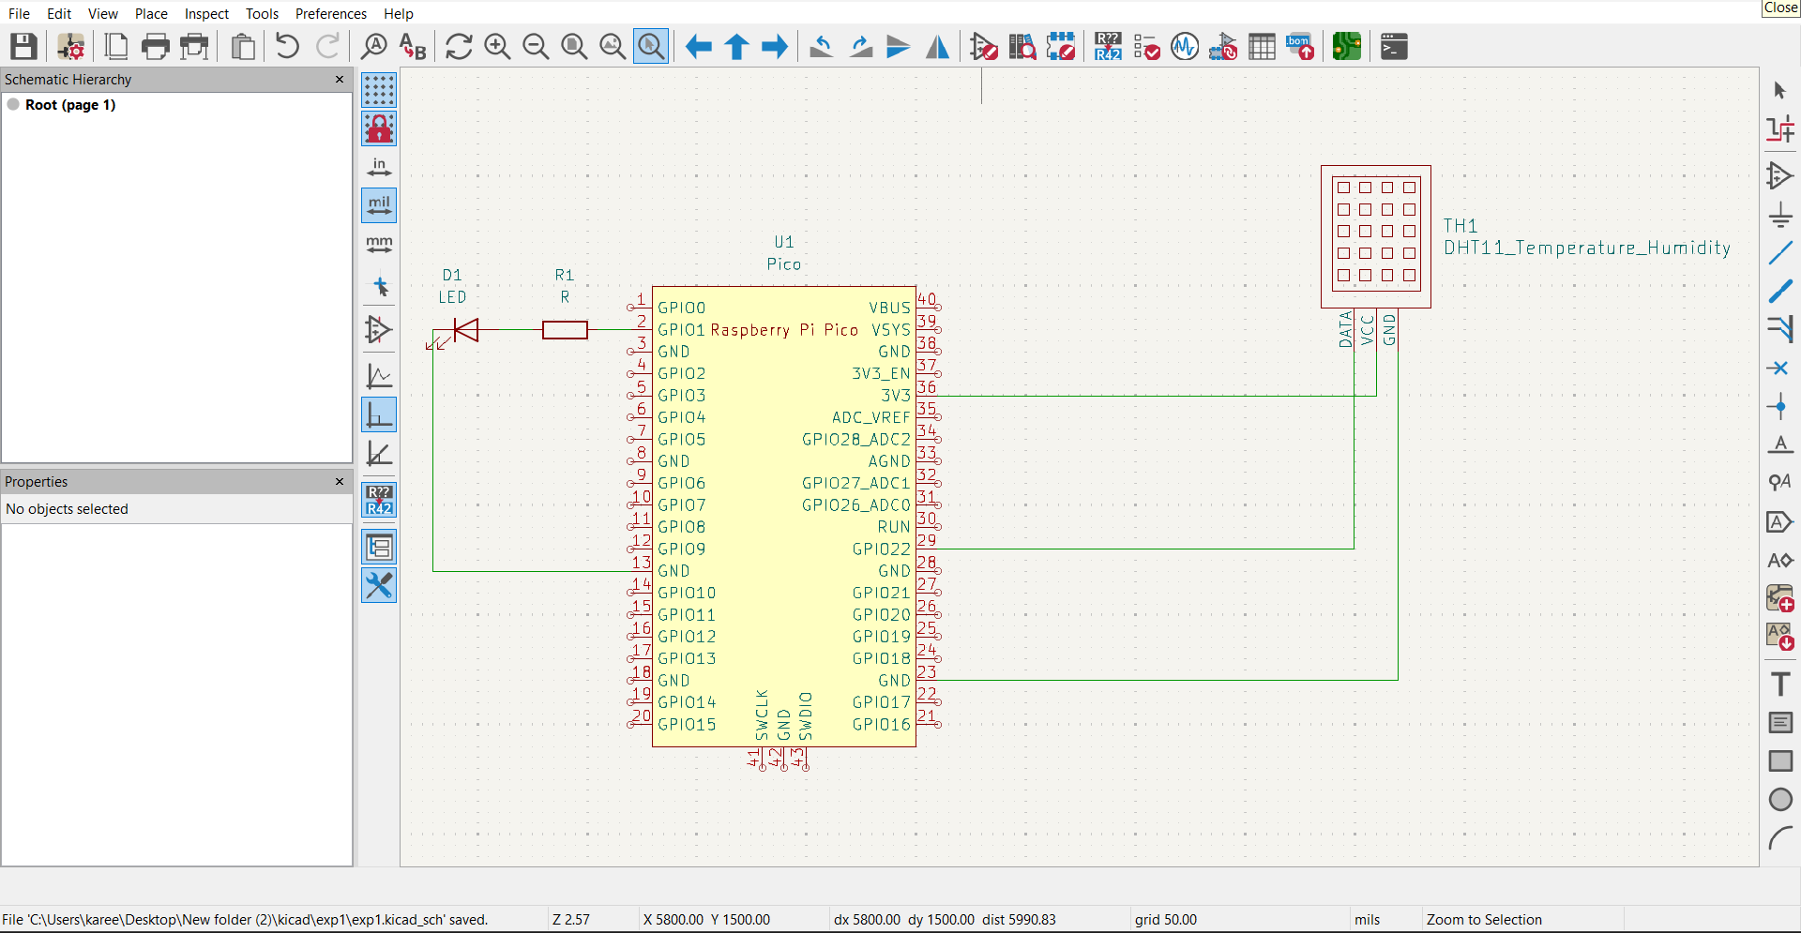

PCB designing:

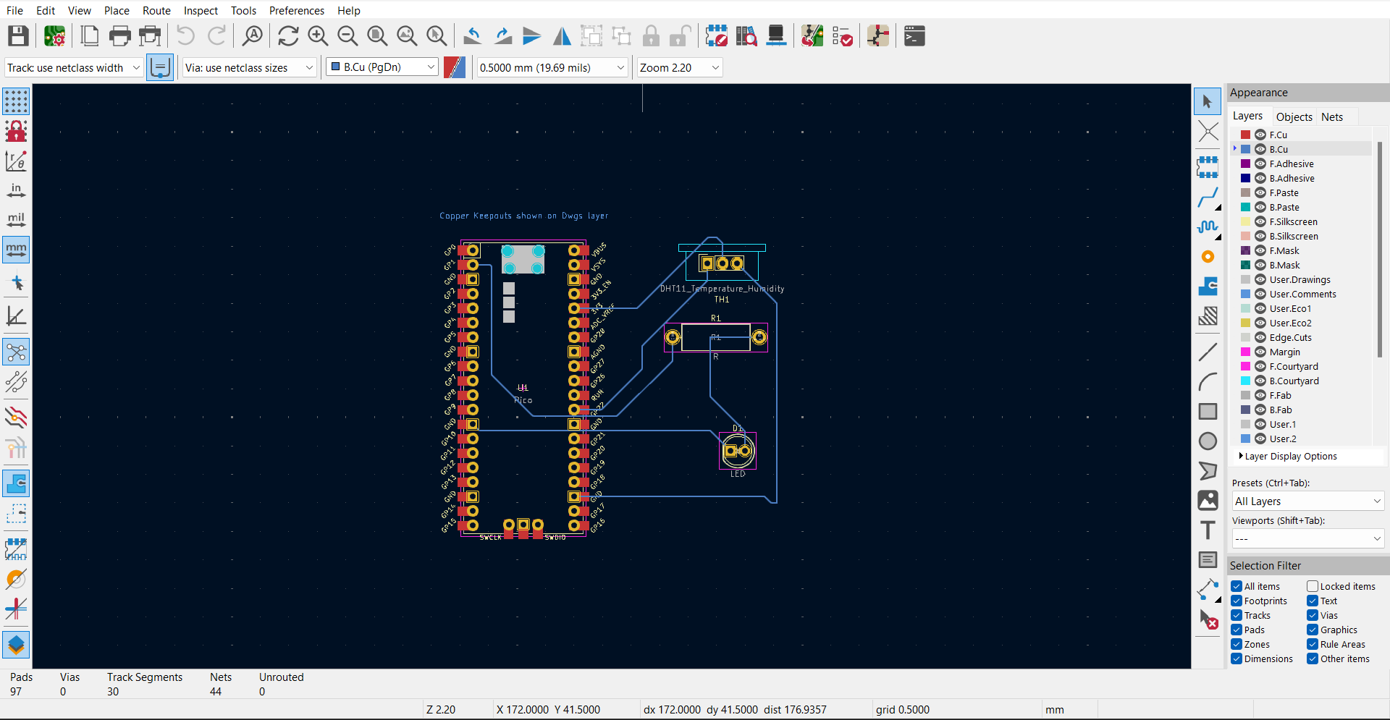

3D Model:

